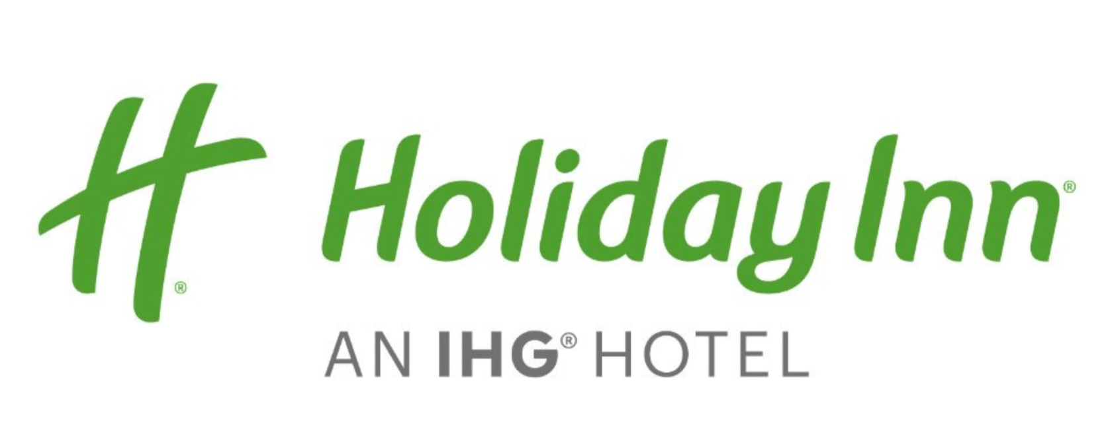

GROUP SALES AGREEMENT
Holiday Day Inn Chicago - Schaumburg
1998 North Roselle Road, Schaumburg, IL 60195
phone: 847-885-0101  fax: 847-885-0404

Highlighted areas must be completed in writing prior to returning to hotel.

The following represents an agreement between: Holiday Inn Schaumburg (the “Hotel”) and Henry Ford College Wrestling (the “Group”) and outlines specific conditions and services to be provided.

Henry Ford College Wrestling (Harper Open)
Grant MacKenzie
5101 Evergreen Rd., Dearborn MI 48128
313-318-4022
grantmackenzie@mac.com
ROOM BLOCK AND RATES
Based upon the Group’s total program requirements as outlined in this agreement, Hotel confirms the following group block and group rates (net of all taxes):

ROOM TYPE | RATE |  | Fri
 |  |  | 01/21/2022
Standard Two Queen | $104.00 |  | 7
Total Rooms/Nights |  |  | 7
*** Rates listed are based upon a per night bases, and are subject to hotel occupancy taxes of 15%. ***

GROUP BLOCK CANCELLATION
The Holiday Inn Schaumburg agrees to reserve the contracted guest rooms to the exclusion of other business opportunities. Should the Henry Ford College Wrestling cancel or reduce any contracted guest rooms after contracted cutoff date, Henry Ford College Wrestling agrees to pay, as liquidated damages and not as penalty, a cancellation fee equal to 100 percent of total unreserved contracted guest room revenue based on the group rate.

RESERVATION PROCEDURES
• Check in time is 3:00pm. Check out is time is 11am.
• Hotel Direct: (847) 985-0101

METHOD OF RESERVATIONS
Upon full execution of this Agreement, Hotel will be holding the Group’s contracted room block for the use of the Group’s attendees. Reservations for the Event will be made by individual attendees directly with reservations, at the property, or online. Shortly after contract execution, the Group will receive detailed booking instructions. In order to assign individuals to specific rooms, room reservations will be required by 01/07/2022.

CUTOFF DATE
Reservations by attendees must be received on or before 1/07/2022 (the “Cutoff Date”). At the Cutoff Date, Hotel will review the quantity of reservations for the Event, release the unreserved rooms for general sale, and determine whether it can accept reservations based on a space- and rate-available basis at the Group’s agreed-to rate after this date.
Release of rooms for general sale following the Cutoff Date does not affect the Group’s obligation, as discussed elsewhere in this Agreement, to utilize guest rooms, or relieve the Group of any obligation noted in this agreement.

BILLING ARRANGEMENTS
Credit card authorization form required prior to confirming rooms. Credit card authorization for sleeping room plus tax only.
Please note that a valid credit card must be presented upon check-in for all incidentals. Cash payment is only permissible upon the date of departure.

INDIVIDUAL RESERVATION CANCELLATION
Hotel allows individual attendees the right to cancel their guest room reservations without penalty up to twenty-four (24) hours prior to the attendees’ scheduled arrival date. Depending on the method of deposit or guarantee, Hotel shall charge the individual attendee or bill the Master Account one night’s guest room rate and tax for cancellation within twenty-four (24) hours of the scheduled arrival date or failure of the individual to check-in on the scheduled arrival date. Any remaining nights of a “no show” reservation will be canceled. It is the Group’s responsibility to share the cancellation policy with their attendees.

PUBLICITY
The Group agrees not to use Hotel’s name, logo or any representation (such as photographs) of Hotel or any portion thereof without first obtaining Hotels written authorization. The Group must provide Hotel with written application for such use, along with examples of the intended use, prior to Hotel considering granting authorization. Hotel will endeavor to respond to any such request from the Group within 15 business days of receipt; provided, however, if Hotel does not respond within such period, authorization for the proposed use will be deemed not to have been granted.

ACCEPTANCE
When presented by Hotel to the Group, this document is an invitation by Hotel to the Group to make an offer. Upon signature by the Group, this document will be an offer by the Group. Only upon signature of this document by all parties will this document constitute a binding agreement. If you cannot make a commitment prior to 12/13/2021, the quoted arrangements are subject to change or, at the Hotel’s option, the arrangements will be released, in which case neither party will have any further obligations. Only upon signature of this document by all parties will this document constitute a binding agreement. Upon signature by both parties, Barbara Arroyo and the Hotel shall have agreed to and executed this Agreement as of the dates indicated below.

SIGNATURES

Approved and authorized by Henry Ford College Wrestling representative:

Name: (Print) ___________________________

Title: (Print) ___________________________

Signature: ___________________________

Date: ___________________________

Approved and authorized by the Holiday Inn Chicago Northwest - Schaumburg:

Name: Rick Ariano

Title: Director of Sales

Signature: ___________________________

Date: ___________________________

